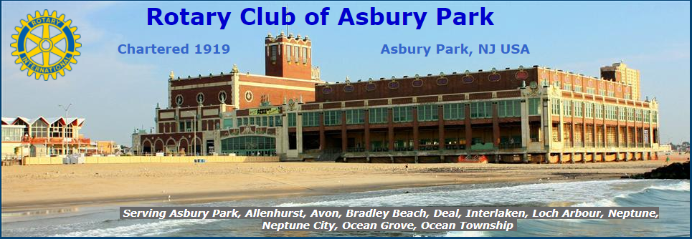
MINI-GOLF
FUNDRAISER
to benefit
asbury parK rotary
&
asbury park fire department aed fund
thursday, August 17
6 to 8 PM
Asbury eighteen
on the boardwalk - $15 per person

